WebEx Quick Start Guide
Logging In:
- Go to iastate.webex.com – Sign In
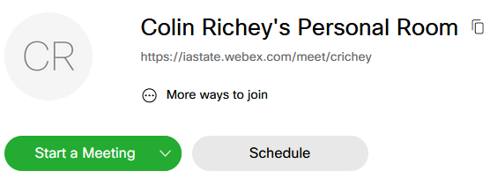
- Login with Okta
Starting a Meeting:
- Click Start Meeting
- The arrow next to ‘Start a Meeting’ will let you choose to host your meeting with the Web App or download and use the Desktop App
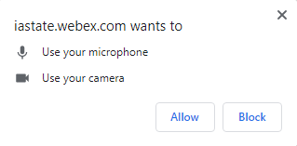
- Make a note of your Meeting URL, you can also find this after starting the meeting by clicking the Info button in the top left corner
- If using the Web App your browser may ask you for permission to use your web cam and/or microphone. Choose Yes or Allow.
Joining a Meeting:
- Other people can join your meeting with your Meeting URL
- They will not need to register for an account, only provide their name for the meeting.
- When they go to your Meeting URL, they will be given the option of downloading the client or using their browser.
During your Meeting:
- You can mute your microphone or stop sending video with the first two buttons
- You can Lock your Meeting using the button with the three dots, this will place anyone that tries to join into a Waiting Room until you admit them
- You can share your desktop or another application with the third button
- You can Record your meeting to be posted later, on Canvas, Youtube, etc.

